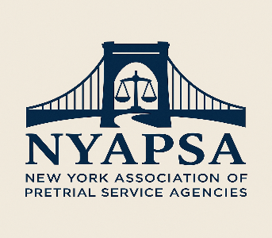

Stacey Fusco (Washington County)
President

Angela Beightol (Niagara County)
Vice-President of Connections

Elizabeth Saba (CJA)
Vice-President of Policy

Sue Mowrey (Washington County)
Secretary

Stacey Fusco, Acting (Wash. County)
Treasurer

David Lowry (CJI)
Director at Large I

Vacant
Director at Large II

Regional Directors:
1. Andrew Cox – Region I
2. Vacant – Region I
3. Juliet Cappelletti – Region II
4. Erin Martin – Region III
4. Kathy McQuade – Region IV
5. Vacant – Region V

New York Association of Pretrial Service Agencies
Mailing Address: Washington County Alternative Sentencing
383 Broadway, Fort Edward, NY 12828
518-746-2347 | www.nyapsa.org
April 21, 2026
A Message from the President
NYAPSA is focused on strengthening and advancing pretrial services across New York State through collaboration, education, and policy leadership.
Over the past year, we have worked to rebuild momentum, strengthen statewide connections, and sharpen our focus on the issues that matter most to local pretrial agencies and the people they serve. That work continues as we position NYAPSA to be a stronger resource for professionals across the state.
As we move forward, our priorities remain clear:
Membership and engagement – building stronger connections among pretrial professionals, encouraging shared learning, and supporting leadership across regions.
Policy and statewide voice – helping elevate the role of pretrial services in New York, strengthening relationships with system partners, and contributing to important conversations about practice, standards, and the future of the field.
We are also looking ahead to the 2026 NYAPSA Conference, which will mark 50 years since NYAPSA’s first conference in 1976. This milestone is an opportunity not only to celebrate the history of pretrial work in New York, but to highlight where the field is headed next.
NYAPSA’s strength has always come from the professionals doing this work every day. We want this organization to reflect the realities, challenges, and innovation happening across the state—and that requires participation, ideas, and partnership from our members and colleagues.
Thank you for being part of that work.
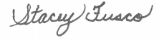
Best,
Stacey Fusco
President, NYAPSA

