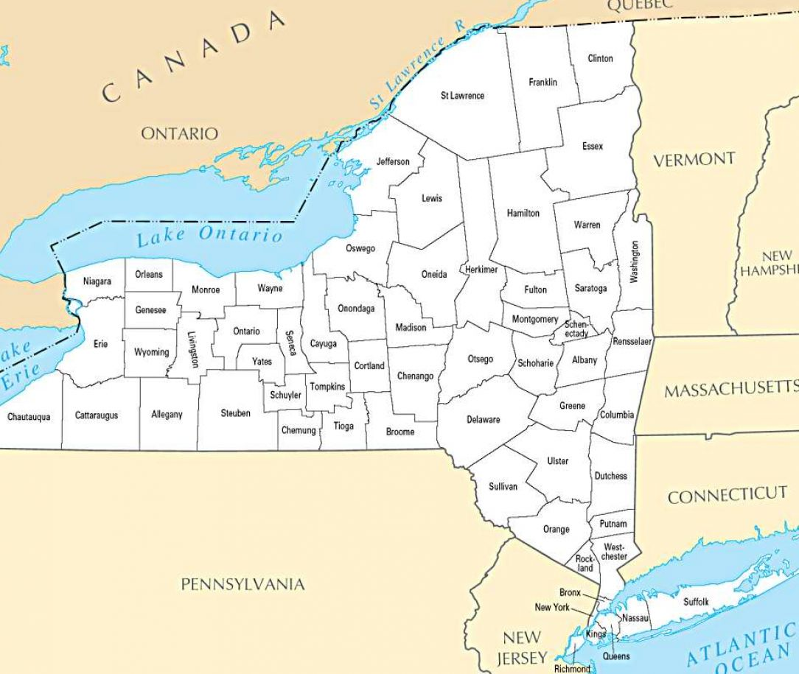

**NYAPSA Board**

President: *Stacey Fusco*

Vice President of Peer Connections: *Angela Beightol*

Vice President of Policy: *Elizabeth Saba*

Treasurer, *Acting: Stacey Fusco*

Secretary: *Sue Mowrey*

Director at Large: *David Lowry*

Director at Large*: Vacant*

Region I Director: *Andrew Cox*

Region I Director: *Vacant*

Region II Director: *Juliet Cappelletti*

Region III Director: *Erin Martin*

Region IV Director: *Kathy McQuade*

Region V Director: *Vacant*

**Region IV**

Albany

Broome

Columbia

Chenango

Delaware

Dutchess

Greene

Orange

Otsego

NYAPSA Regions

**Region III**

Allegany

Cattaraugus

Cayuga

Chautauqua

Chemung

Cortland

Erie

Genesee

Livingston

Monroe

Niagara

Onondaga

Ontario

Orleans

Schuyler

Seneca

Steuben

Tioga

Tompkins

Wayne

Wyoming

Yates

**Region II**

Nassau

Suffolk

**Region I**

Bronx

New York

Kings

Queens

Richmond

Putnam

Rensselaer

Rockland

Schenectady

Schoharie

Sullivan

Ulster

Westchester

**Region V**

Clinton

Essex

Franklin

Fulton

Hamilton

Herkimer

Jefferson

Warren

Washington

Lewis

Madison

Montgomery

Oneida

Oswego

Saratoga

St. Lawrence